

jPager

Table of Contents

Discovery 3

Idea 3

User Stories 3

Proposed Technology 3

Design 4

Entity Relationship Diagram (ERD) 4

Jobs 4

Priorities 4

User_Jobs 5

Departments 5

Escalation_Levels 5

Users 5

Department_Escalation 5

Notes 6

User Interface 6

1 - Login 6

2 - Job_Alerts 7

3 – View Reference Table Info 8

4 – Delete 8

5 – Add 8

Departments 9

Department_Escalation 9

Jobs 9

Priorities 9

User_Job 10

Users 10

# Discovery

## Idea

Many companies have batch job scheduling systems that sends emails when a job fails. Most of these emails end up sitting in an inbox with no accountability until someone get into the office and notices either the failure or the email.

This new application, jPager, will provide an accountable escalation notification system.

## User Stories

An individual contributor (IC) will be notified by email and text message when a job fails. If the IC fails to reply within a specified tolerance time period (for example: 5 minutes for a critical job, 60 minutes for a medium priority job and 180 minutes for a low priority job) the next person in the escalation chain is notified (for example, manager) and the IC is informed that the manager has been notified.

This sequence of events continues up the escalation chain (IC to manager to director to managing director to CTO to president) until someone replies or the escalation chain is exhausted.

## Proposed Technology

Front end: HTML / JavaScript / CSS / Bootstrap

Back end: NoSQL (reference tables) & Block Chain (transactions)

# Design

## Entity Relationship Diagram (ERD)

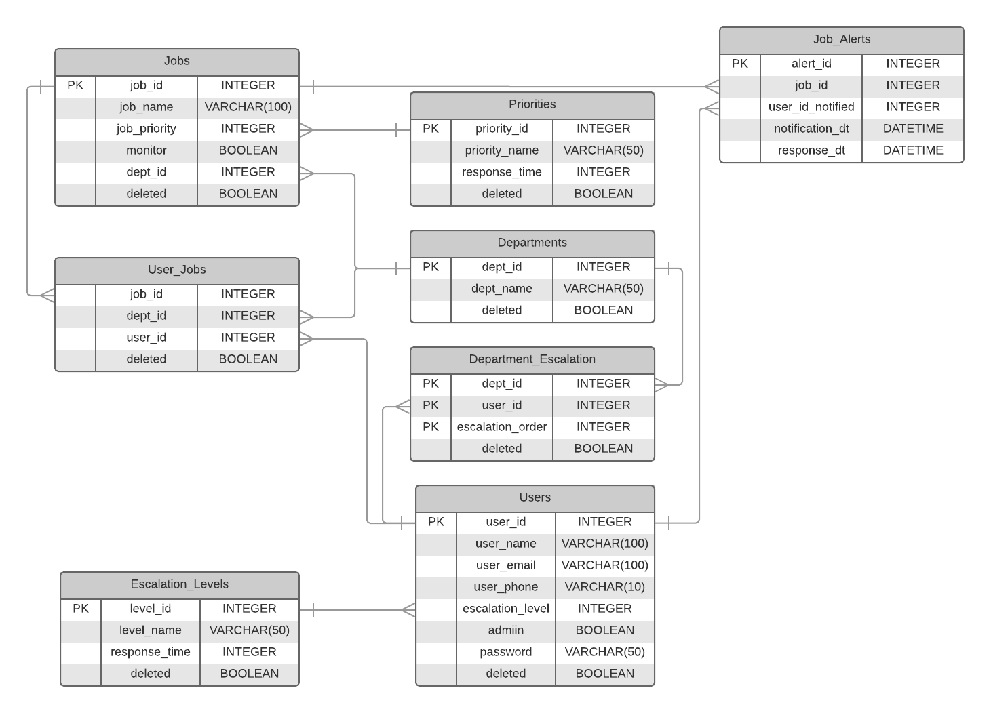

### Jobs

Reference table that contains a list of jobs to monitor.

|  |  |  |  |
| --- | --- | --- | --- |
| **Key** | **Name** | **Type** | **Description** |
| PK | job_id | Integer | Unique job identifier |
|  | job_name | Varchar | Job name |
|  | job_priority | Integer | Job urgency to business |
|  | monitor | Boolean | Flag to monitor this job |
|  | dept_id | Integer | Department that owns this job |
|  | deleted | Boolean | Flag to mark this job as deleted |

### Priorities

|  |  |  |  |
| --- | --- | --- | --- |
| **Key** | **Name** | **Type** | **Description** |
| PK | priority_id | Integer | Unique priority identifier |
|  | priority_name | Varchar | Priority name { ‘Critical’, ‘High’, ‘Medium’, ‘Low’ } |
|  | response_time | Integer | Required response time in minutes |
|  | deleted | Boolean | Flag to mark this job as deleted |

Job_Alerts

|  |  |  |  |
| --- | --- | --- | --- |
| **Key** | **Name** | **Type** | **Description** |
| PK | alert_id | Integer | Unique alert identifier |
|  | job_id | Integer | Job id that issued this alert |
|  | user_id_notified | Integer | User id that has been notified about this alert |
|  | notification_dt | Datetime | Date and time user id was notified |
|  | response_dt | Datetime | Date and time user id responded to alert |

### User_Jobs

|  |  |  |  |
| --- | --- | --- | --- |
| **Key** | **Name** | **Type** | **Description** |
|  | job_id | Integer | Job identifier |
|  | dept_id | Integer | Department identifier |
|  | user_id | Integer | User identifier |
|  | deleted | Boolean | Flag to mark this job as deleted |

### Departments

|  |  |  |  |
| --- | --- | --- | --- |
| **Key** | **Name** | **Type** | **Description** |
| PK | dept_id | Integer | Department identifier |
|  | dept_name | Varchar | User identifier |
|  | deleted | Boolean | Flag to mark this job as deleted |

### Escalation_Levels

|  |  |  |  |
| --- | --- | --- | --- |
| **Key** | **Name** | **Type** | **Description** |
|  | level_id | Integer | Unique level identifier |
|  | level_name | Varchar | Escalation level name |
|  | response_time | Integer | Required response time in minutes |
|  | deleted | Boolean | Flag to mark this escalation level as deleted |

### Users

|  |  |  |  |
| --- | --- | --- | --- |
| **Key** | **Name** | **Type** | **Description** |
|  | user_id | Integer | Unique user identifier |
|  | user_name | Varchar | User name |
|  | user_email | Varchar | User email address |
|  | user_phone | Varchar | User phone number |
|  | admin | Boolean | Flag to indicate user is an administrator |
|  | password | Varchar | User password |
|  | deleted | Boolean | Flag to mark this escalation level as deleted |

### Department_Escalation

|  |  |  |  |
| --- | --- | --- | --- |
| **Key** | **Name** | **Type** | **Description** |
| PK | dept_id | Integer | Department identifier |
| PK | user_id | Integer | User identifier |
| PK | escalation_order | Integer | Escalation order (1-number of users to notify) |
|  | deleted | Boolean | Flag to mark this escalation level as deleted |

### Notes

1. To maintain referential integrity admin users will only be able to add new reference table entries or mark an existing record as deleted
2. When a job alert is received Job_Alerts.response_dt will be null. Once a user responds to the job alert a new block will be created with the response_dt populated.

# User Interface

There are 2 user types for this application:

|  |  |
| --- | --- |
| Subordinate | Has read only access to all tables within their department |
| Administrator | Has write access to all reference tables in all departments and read access to job alerts |

To speed up development time Bootstrap templates will be used whenever possible [https://www.w3schools.com/bootstrap/default.asp]

Application flow will be the same for both user types. The only difference will be an administrator will see 2 additional buttons Add & Delete on most forms.

The images below are only electronic images of hand drawn screen images. They are only meant to represent how the forms will work. They are **not** meant to convey in any way, shape or form how the actual form will look.

If time permits, in phase 2, filtering will be added.

The following sections demonstrate user interaction.

## 1 - Login

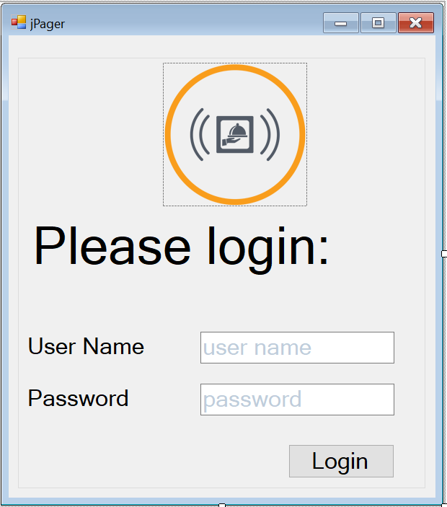

## 2 - Job_Alerts

This will be the main (home / landing) page. With a navigation bar (menu) providing access to all other pages (forms).

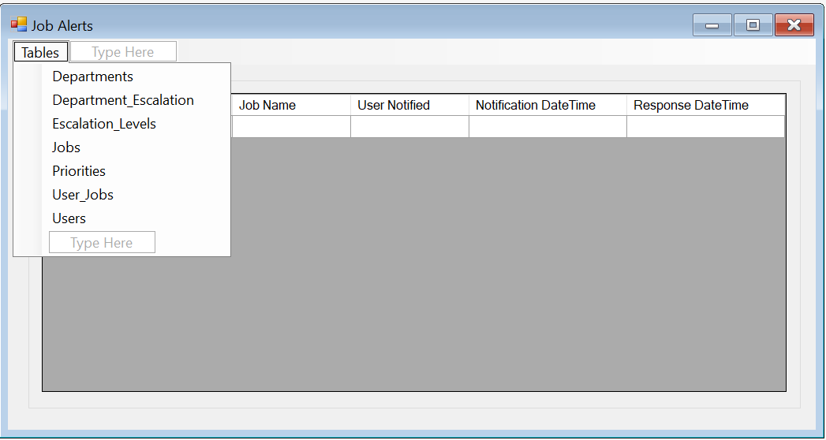

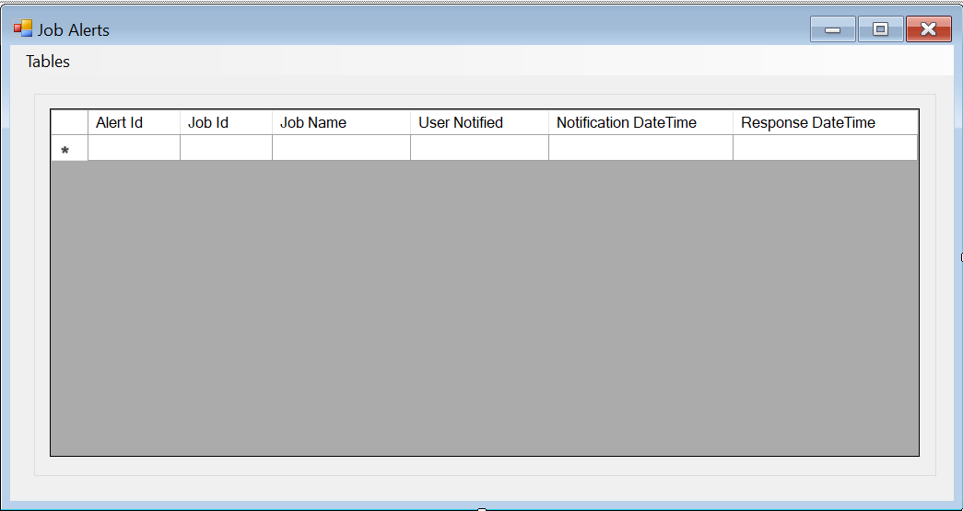

Note: Job Alerts is read only

## 3 – View Reference Table Info

The remaining reference tables (Departments, Department_Escalation, Jobs, Priorities, User_Jobs and Users) will all follow a similar format. The difference is the columns displayed in the grid will change depending on the source. For simplicity and brevity only one is shown below.

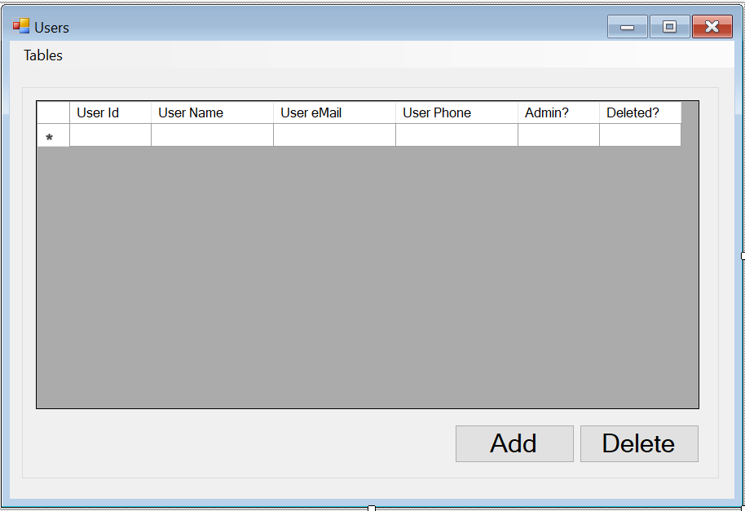

## 4 – Delete

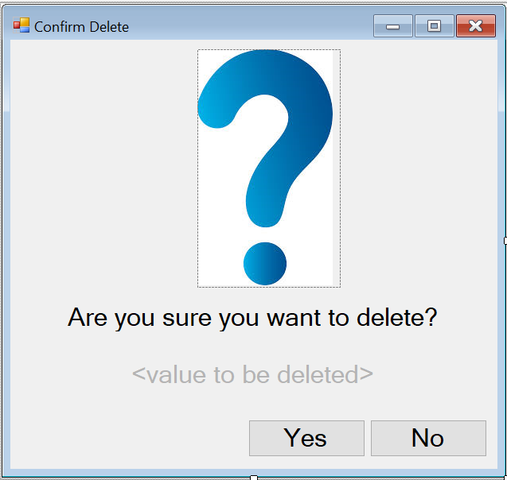

Show user confirmation and take appropriate action based on user selection.

## 5 – Add

An interface will be provided for adding Departments, Department_Escalation, Jobs, Priorities, User_Jobs and Users. This interface might be:

1. an expanding grid entry
2. a separate page (form)
3. adding a new row to the grid for the user to enter required data.

The separate page (form) solution is shown below.

### Departments

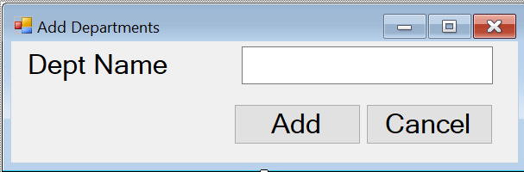

### Department_Escalation

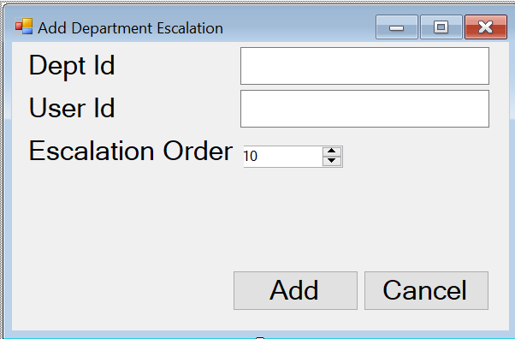

### Jobs

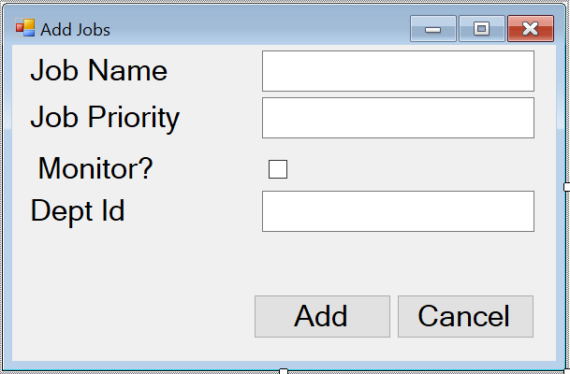

### Priorities

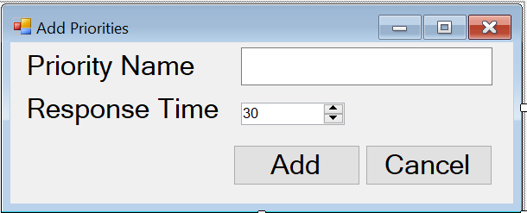

### User_Job

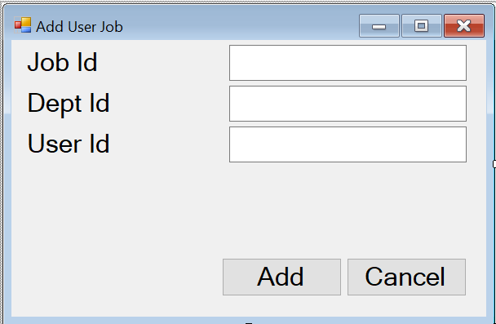

### Users

